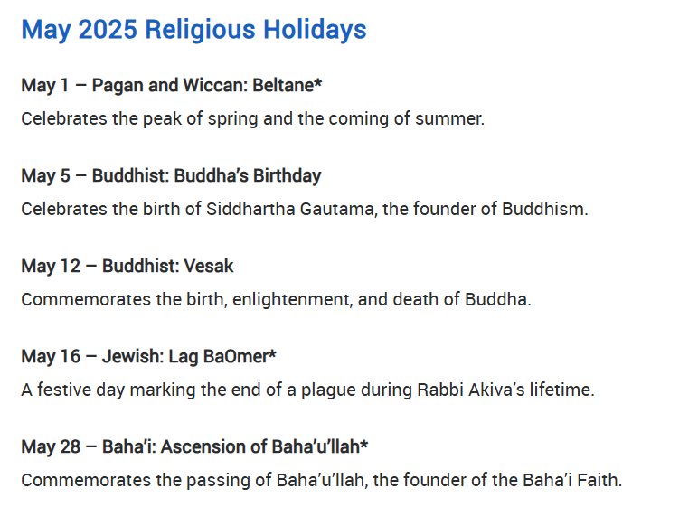
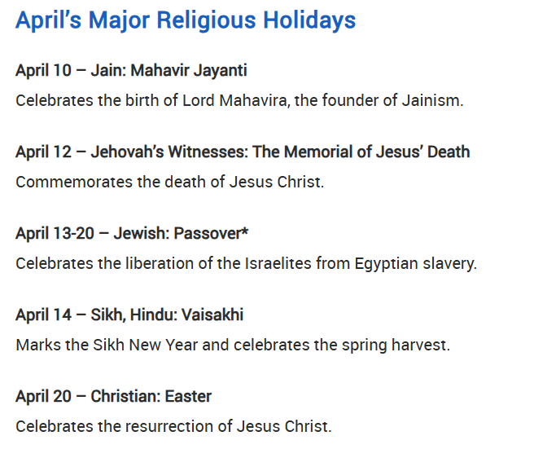

Term 6 (Animals)
Key
Predominant learning subject/activity
EYFS composite

CL
- Literacy lessons, group times, singing, drama and story times.
- Articulate their ideas and thoughts in well-formed sentences.
- Learn rhymes, poems and songs.
- Use talk to help work out problems and organise thinking and activities, and to explain how things work and why they might happen
- Offer explanations for why things might happen, making use of recently introduced vocabulary from stories, non-fiction, rhymes and poems when appropriate.
- Retell stories, once they have developed a deep familiarity with the text, some as exact repetition and some in their own words.
- Express their ideas and feelings about their experiences using full sentences, including use of past, present and future tenses and making use of conjunctions, with modelling and support from their teacher.
PD
- PE, art, Dough Disco, Forest School and fine motor tuft trays.
- Develop their small motor skills so that they can use a range of tools competently, safely and confidently.
- Confidently and safely use a range of large and small apparatus indoors and outside, alone and in a group.
- Begin to show accuracy and care when drawing.
- Develop the foundations of a handwriting style which is fast, accurate and efficient.
UTW
- Forest School (Summer), lessons about animals who live in oceans, rivers, forests, desserts, farms and pets.
- Know some similarities and differences between the natural world around them and contrasting environments, drawing on their experiences and what has been read in class.
- Know some similarities and differences between different religious and cultural communities in this country, drawing on their experiences and what has been read in class.
Literacy
- Literacy lessons, RE, Phonics, role-play, exploring rhyme and story times.
- Write recognisable letters, most of which are correctly formed.
- Form lower-case and capital letters correctly.
- Write short sentences with words with known sound-letter correspondences using a capital letter and full stop.
- Spell words by identifying sounds in them and representing the sounds with a letter or letters.
- Say a sound for each letter in the alphabet and at least 10 digraphs.
- Re-read what they have written to check that it makes sense.
- Read aloud simple sentences and books that are consistent with their phonic knowledge, including some common exception words.
- Demonstrate understanding of what has been read to them by retelling stories and narratives using their own words and recently introduced vocabulary.
EAD
- Music, dance and art.
- Explore, use and refine a variety of artistic effects to express their ideas and feelings.
- Return to and build on their previous learning, refining ideas and developing their ability to represent them.
- Create collaboratively, sharing ideas, resources and skills.
- Sing in a group or on their own, increasingly matching the pitch and following the melody.
- Explore and engage in music making and dance, performing solo or in groups.
- Share their creations, explaining the process they have used.

PSED
- Relationships (i.e. friendships, PSHE) and group times.
- Build constructive and respectful relationships.
- Express their feelings and consider the feelings of others.
- Show resilience and perseverance in the face of challenge.
- Explain the reasons for rules, know right from wrong and try to behave accordingly.
- Think about the perspectives of others.
Maths
- Maths lessons on: Sharing and grouping, building numbers, number formation building and mapping and addition and subtraction.
- Have a deep understanding of number to 10, including the composition of each number.
- Automatically recall number bonds for numbers 0 to 5 and some to 10.
- Compare quantities up to 10 in different contexts, recognising when one quantity is greater than, less than or the same as the other quantity.
- Continue, copy and create repeating patterns.
- Link the number symbol (numeral) with its cardinal number value.

