Headteacher: Mrs B P Lee Gladstone Road
Tel: 01173772373 Hengrove
E-Mail stbernadettep@bristol-schools.uk Bristol
http://www.st-bernadette-pri.bristol.sch.uk BS14 9LP

Pre-School Newsletter
WB: 20/10/25

Dear Parents and Carers,
We hope our newsletter finds you well. We hope you all had a lovely, restful half term. The children have settled back in very well.

General reminders/information

We are very fortunate to have such a lovely, outdoor, back garden with access to the forest school area too. We would love for the children to start being able to ‘free-flow' between the outside space and the inside classroom. We will be spending as much time as the children wish outside, therefore we will be needing welly boots, waterproof trousers (if you have any) and nice warm winter coats (labelled).
From next week we will now be entering via the sheltered front door so the children can go straight into 'free-flow' play and exiting from the right hand door (signs will be up). This will be starting from next week, Monday 10th October.

The lunch trolley will be under the shelter at the end of the day from next week, please can you ensure you collect your child’s lunch box at pick-up time.

Please see below a message from The Friends of St Bernadette’s:
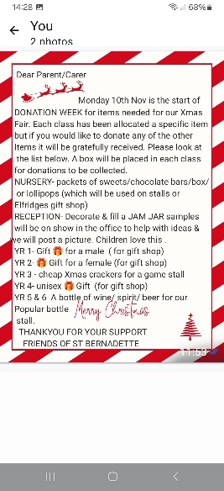

- If your child was born between 1 September 2021 and 31 August 2022 or your child has agreement to delay entry to primary education until September 2026 you need to apply for a new reception school place to your home local authority. You need to apply by 15 January 2026.

Dates for your diary
- Wednesday 19th November- For our new topic ‘Animals and their habitats’ we would like to invite the children to dress up as their favourite animal! (Any animal will be great!)

- Monday 15th December or Thursday 18th December- We welcome you to join us for a festive stay and play to create some lovely festive crafts. Times are 2:00pm – 2:50pm. Please choose one of the sessions to attend. You are welcome to take your child home after.

- Wednesday 17th December- We would love to come together, as a whole class, to sing some lovely festive songs for you and pop them on Tapestry for you to see. For us to be able to do this, we would like to invite the ‘End of week children’, to join us for the morning session 9-12pm (instead of their usual afternoon session). This would allow us to all be together to sing our Christmas songs as a group. Please let us know if this would be possible so we know if we can expect your child in on this morning. Christmas jumpers to be worn please

- Friday 19th December- Last day of term 2.
- Monday 5th January – INSET – school closed for staff training.
- Tuesday 6th January – Return to school for term 3.

Please ask a member of staff if you have any questions. Thank you for your continued support,

The Pre-School Team

