Headteacher: Mrs B P Lee Gladstone Road
Tel: 01173772373 Hengrove
E-Mail stbernadettep@bristol-schools.uk Bristol
http://www.st-bernadette-pri.bristol.sch.uk BS14 9LP

Pre-School Newsletter
WB: 22/09/25

Dear parents and carers,
We hope our newsletter finds you well. We have been continuing our ‘Families and Feelings’ topic this week and looking at houses we live in using the photos of our own homes.
We have also explored our new classroom The ‘Daisy’ Room!

General reminders
- Please can you ‘like’ or comment on your child’s tapestry post so we can see if you are engaging with the app and viewing the posts. The staff put a lot of time and effort into these posts and it will be lovely to see that they are being seen and enjoyed.
- Please can you send a snack in for your child (separate from their lunch box) in a named tub/packet. This could be breadsticks, rice cakes, an extra piece of fruit or chopped up mix of fruits.
- Please can we ask that your child’s packed lunch is as healthy as possible and including some form of fruit and vegetables.

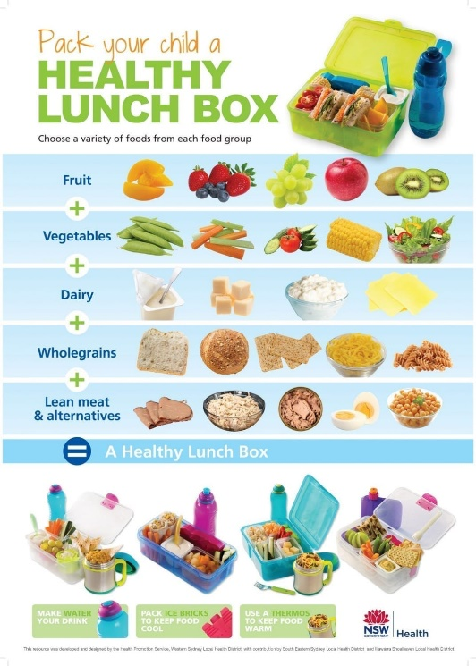

Dates for your diary

- Thursday 2nd October - School photos. If your child doesn’t attend pre-school on a Thursday, you are welcome to take them into the hall at 8:30am to have their photos taken by the photographer.
- Stay and play sessions- Soon we will be holding ‘stay and play’ sessions for you to come into pre-school to join us for some lovely activities with your child. These sessions will be on 14th October for the beginning of the week children and 16th October for the end of week children. If your child is full-time you can choose which one you would like to attend. The sessions will run from 2:10pm-2:50pm. You will be able to take your child home after.
- Friday 24th October – Last day of term 1. We will return to school on Monday 3rd November for term 2.

Please ask a member of staff if you have any questions. Thank you for your continued support,

The Pre-School Team

