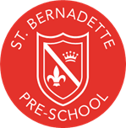

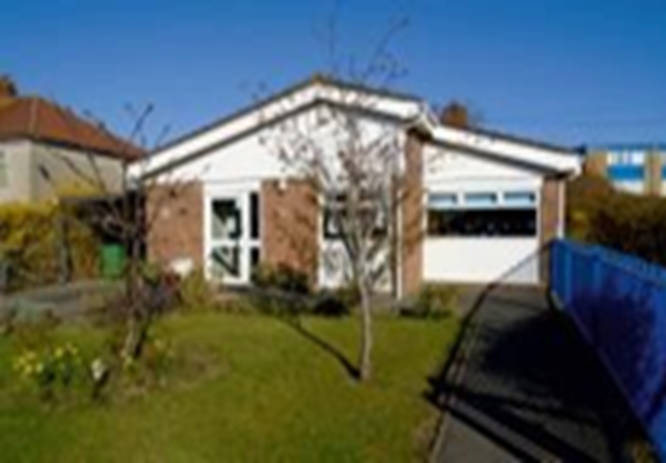

Curriculum Information
For Parents & Carers

St Bernadette Pre-School,
Gladstone Road
Bristol
BS14 9LP

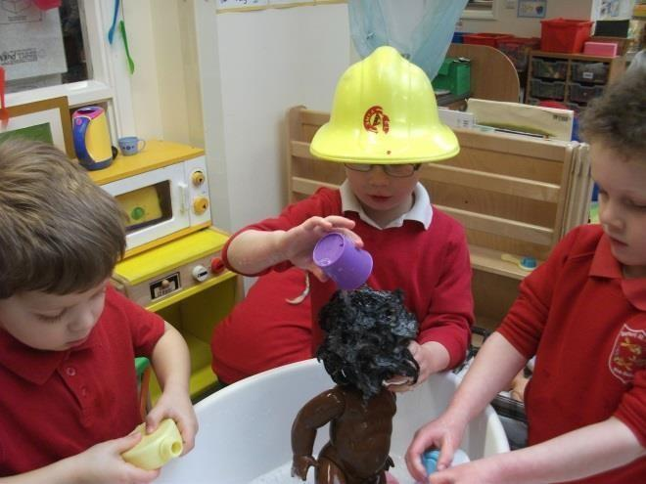

Curriculum
St Bernadette Pre-school supports all children in developing at their own pace. Our Key Worker system enables us to observe, evaluate and ensure a planned curriculum that meets the needs and interests of each individual child. We realise the importance for children to have rich and stimulating experiences within the learning environment providing many opportunities for the children to explore, experiment, plan and make decisions, therefore enabling them to learn and develop.
We organise our sessions so that the children can choose from, and work at, a range of activities and in doing so, build up their ability to select and work through a task to its completion. The children are also helped and encouraged to take part in adult-led small and large group activities, which introduce them to new experiences and help them to gain new skills, as well as helping them to learn to work with others.
Our outdoor activities contribute to children’s health and well- being, their physical development and their knowledge of the world around them.
The children have the opportunity, and are encouraged, to take part in both indoor and outdoor activities.
The setting also caters for children’s individual needs for rest and quiet activities during the day.
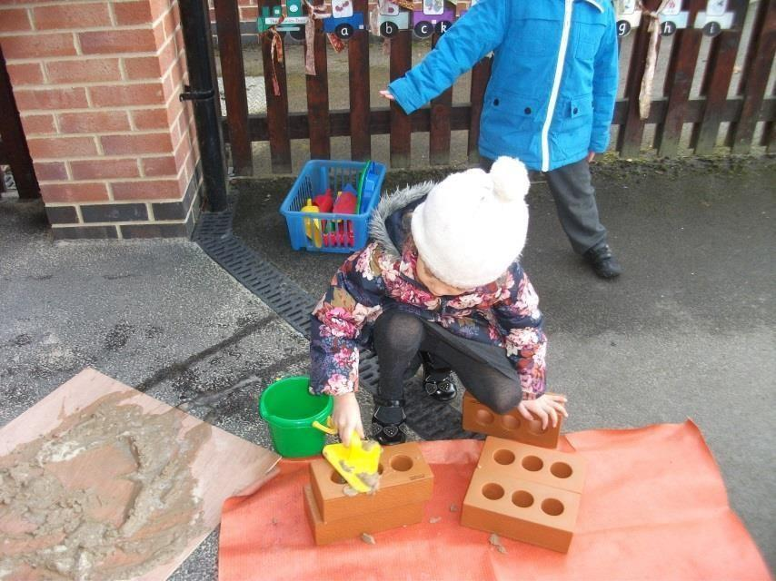

The Early Years Foundation Stage
Every child deserves the best possible start in life to fulfil their potential. A secure, safe and happy childhood is important in its own right, and provides the foundation for children to make the most of their abilities and talents as they grow up. The Early Years Foundation Stage (EYFS) is the framework that provides this.
Below lists the education programme we follow for each area of learning:-
Personal, Social and Emotional Development
Children are provided with experiences and support to help develop a positive sense of themselves and others, social skills and a positive disposition to learn.
Physical Development
The physical development is encouraged through opportunities for them to be active and interactive and to improve their skills of co-ordination, control, manipulation and movement. They are supported in using all of their senses to learn about the world around them and to make connections between new information and what they already know. They are supported in developing and understanding the importance of physical activity and healthy choices in relation to food.
Communication and Language
Children’s learning and competence in speaking, understanding, listening and attention is supported and extended.
Literacy
Opportunities are provided to encourage and support reading and writing.

Mathematics
Children are provided with opportunities to develop problem solving skills and familiarity with numbers, shapes, measurements and space, therefore gaining confidence and competence in their use.
Understanding the World
Children are supported to help them make sense of the world. They are offered opportunities to use a range of tools safely, encounter creatures, people, plants and objects in their natural environments and real-life situations, undertake practical ‘experiments’ and work with a range of materials and technology.

Expressive Arts and Design
Children are provided with opportunities to explore and share their thoughts, ideas and feelings through art, music, movement, dance, imaginative, and role- play activities.

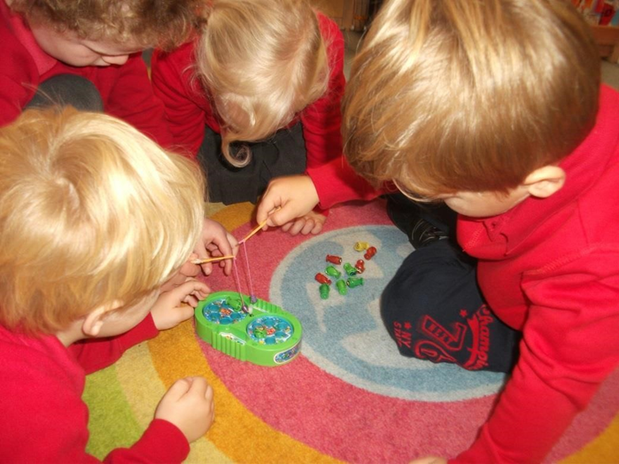
The curriculum is planned to encourage children:
- to engage in co-operative play
- to engage in both child and adult-led activities
- to apply knowledge, skills, attitudes and practical abilities that will become a firm foundation for future learning and a resource from which further development will draw meaning
- to move towards acquiring a reasoned set of attitudes, behaviour and values, including a respect for other children’s race and culture
- to develop a good self-image, self-motivation and independence
- to look outside themselves, to begin to appreciate other points of view and to represent objects and situations in their play.
- to appreciate creative thought and action through art, music, drama and dance and to experience some personal achievement in these
- to develop personal agility, physical co-ordination and confidence in movement
- to develop an enjoyment and appreciation of the literature, language and music of other cultures as well as their own
- to develop an awareness of the total environment of the school and its community and encourage the development of investigation, observation and some awareness of cause and effect.

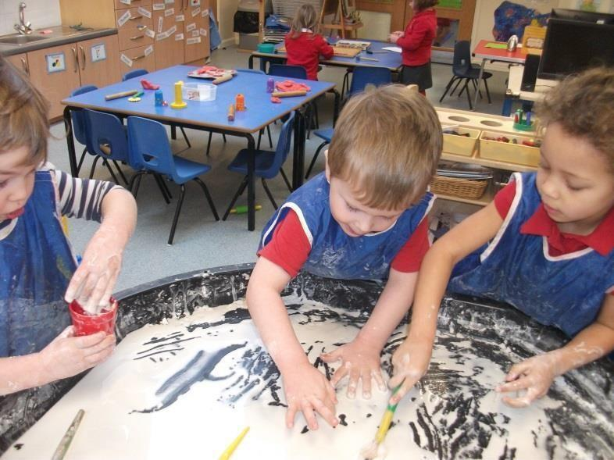
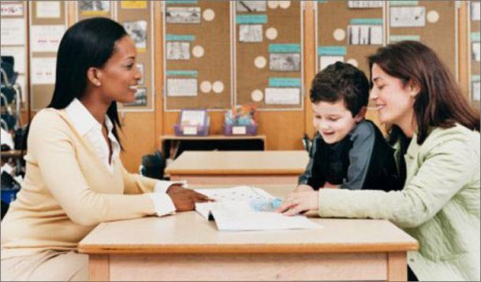

Keeping you informed

The Key Person System is in place to ensure that each child is cared for and treated as an individual. Each practitioner has a small group of children who they will monitor, observe and keep records for, during their time at Pre-School. This is the person who parents can liaise with and discuss any concerns or achievements as required.
Throughout your child’s time in Pre-school you will receive a variety of communications to keep you up to date with what your child is doing at Pre-school. Information will also be available in the pre-school newsletter and the school’s newsletter, our pre-school is very much part of the wider school activities.
You will also be given information about your child’s progress through Tapestry which is an online learning diary. This will contain a record of their achievements through observations of their play, photographs and examples of their own activities, such as mark making or artwork. Throughout your child’s time with us, we will organise stay and play sessions to which you will be invited to come in and play with your child
There will also be opportunities for parents/carers to attend progress meetings which is a chance to discuss your child’s progress with their keyworker.
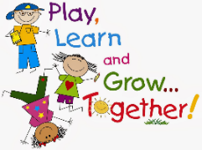
Your contributions to Tapestry are very welcome as they help form the link between home and school for your child.

