St Bernadette Catholic Primary School
‘Living and Learning through Christ’


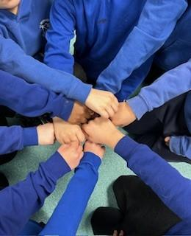

Home-School Agreement
2024 - 2025

School Agreement
St Bernadette School will do its best to:
- Provide a safe and secure learning environment where we encourage our children to embrace our school values of kindness, love, tolerance, respect and forgiveness
- Teach and encourage the children to do their best and achieve their potential
- Monitor the progress of the children and provide advice and guidance to support their learning
- Promote high standards of behaviour to support a safe and caring environment
- Treat children fairly and with respect
- Help your child to develop a sense of responsibility and support them to make the right choices
- Be welcoming and offer opportunities for families to become involved in the life of the school
- Encourage good attendance and punctuality
- Invite parents/Carers to attend events that celebrate children’s success and achievement
- Keep parents informed about school activities through newsletters, emails, website etc

Signed……………………............................... Date…………………………




Parent/Carer Agreement
I/We will do my/our best to:
- Ensure my child attends school every day, on time and with everything they need for the day ahead
- Contact school if my child is absent
- Ensure that my child wears the correct school uniform and PE kit
- Support my child with home learning (reading, spellings, X Tables)
- Attend meetings to discuss my child’s progress
- Treat all members of the school community with kindness and respect
- Work in partnership with the school

Signed……………………………………… Date…………………………

Child’s Agreement
I will do my best to:
- Come to school every day and arrive on time
- Always try my hardest
- Behave well and be polite to others
- Follow the school and class rules
- Take responsibility for myself and my actions
- Take good care of school equipment and the school environment

Child’s Name …………………………………………..

Class………………………………………………………

Date: …………………………………………………….



